Nelson
Hello, my name is Brian Harmer. I am happily retired, a lifelong photography enthusiast and a member of the Hutt Camera Club. I am a holder of the LPSNZ and am struggling to achieve my “A”. I have enjoyed looking at your images and, as requested by your competition secretary, offering a very brief comment on each of them. Please accept my remarks as you should for all judges, as just one person’s opinion, and if I have got something wrong please forgive me and hope for better things from another judge.
File name | Image | Assessment
A Grade
01 Saturday-5am | 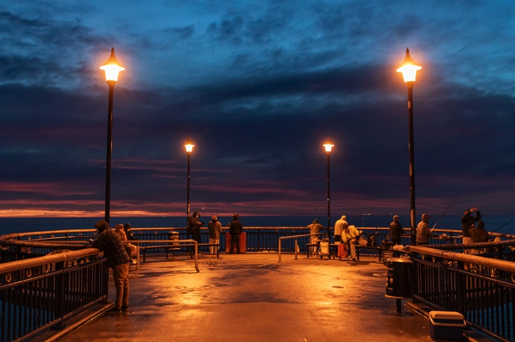 | The atmosphere of fishing in the pre-dawn cold and damp are well portrayed in this image. The composition is pleasing and I like the symmetry of the shot along the centre-line of the pier. Might a reduction of the highlights around the four lights reduce the impression that they are overexposed? The promise of the new day is well caught | Accepted
02 Autumn-Outlook | 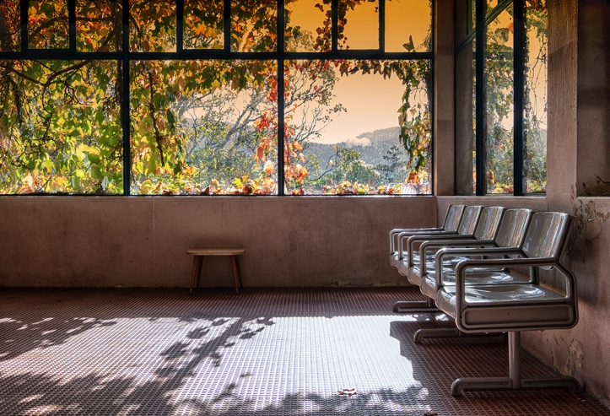 | The warm Autumn colours in the top half of the image are pleasing. The shadows on the floor and the lines of the seats all lead us to the windows. At the same time, I find the plastic seats to be a significant distraction, almost as if they were the subject of the picture. I wonder if the picture needs a person in the it, or perhaps to lose the lower half . | Accepted
03 Australian-Bustard-Stretching-its-Wing | 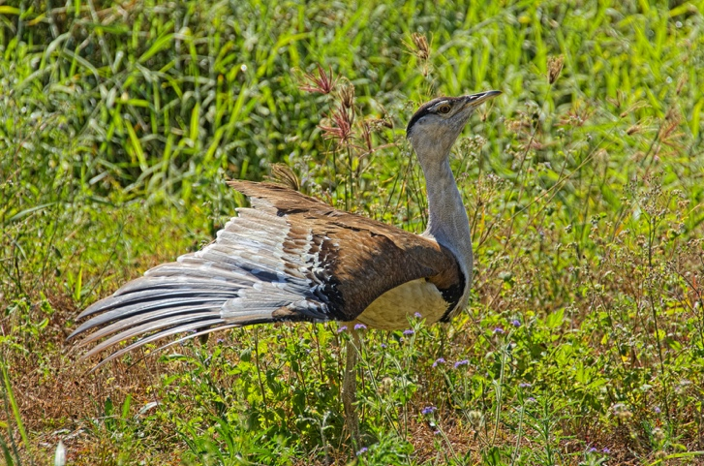 | This is a nice study of the bird in what I assume to be its natural habitat. The eye is sharp and the whole image is well exposed. The depth of field is well managed to include the blue flowers in the foreground, and to allow the background grasses to blur. | Accepted
04 Rocks-Risen-after-Kaikoura-Earthquake | 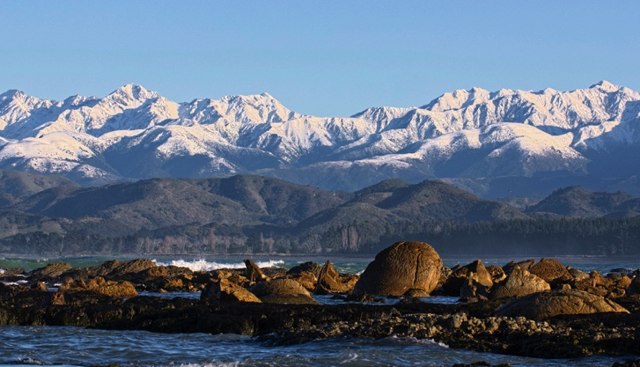 | A receding series of planes always works for me. From the sandbar to the line of dominant rocks to the foreshore, the hills and the mountains, it all works quite well together. | Accepted
05 Cross-in-the-Water | 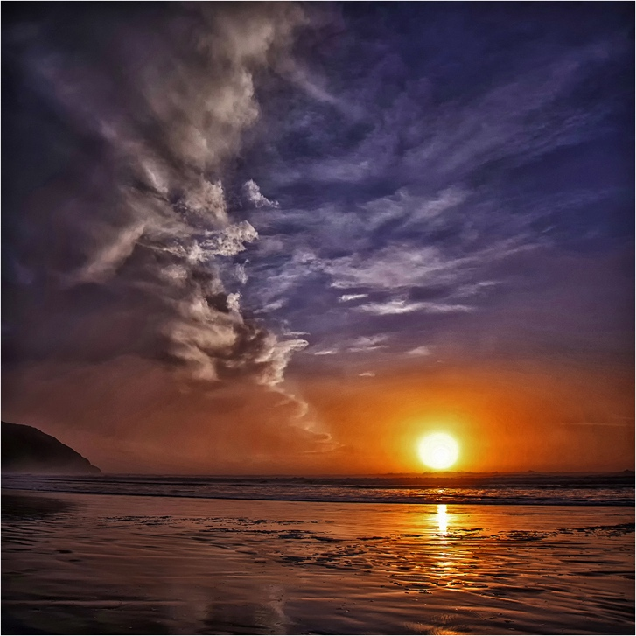 | This striking image brings together the sunset, the high clouds on the right and to my mind, the dominating cloud front coming in from the left. It is almost a competition between the well-seen cross in the water and that wonderful wall of cloud. | Merit
06 Effervescence | 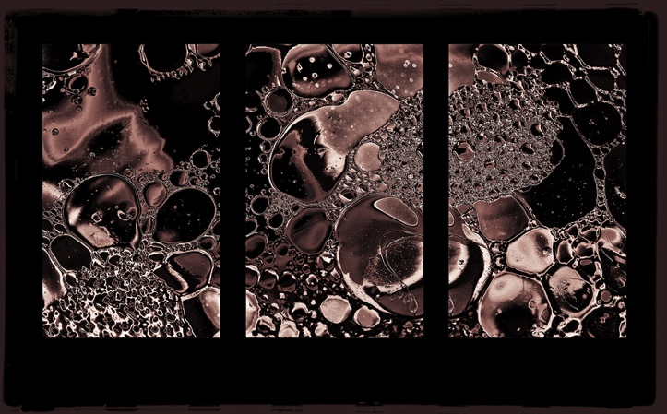 | So much is happening in this triptych that I am not sure where I should be looking. I love the palette and the textures. The triptych appears to have been made by selecting three slightly overlapping parts of a single exposure, and in my opinion any one of the three is an interesting image in its own right. I wonder whether the three part treatment makes a better image than what I presume to be the original single shot? Nevertheless, it is a pleasing image | Merit
07 Out-In-The-Cold | 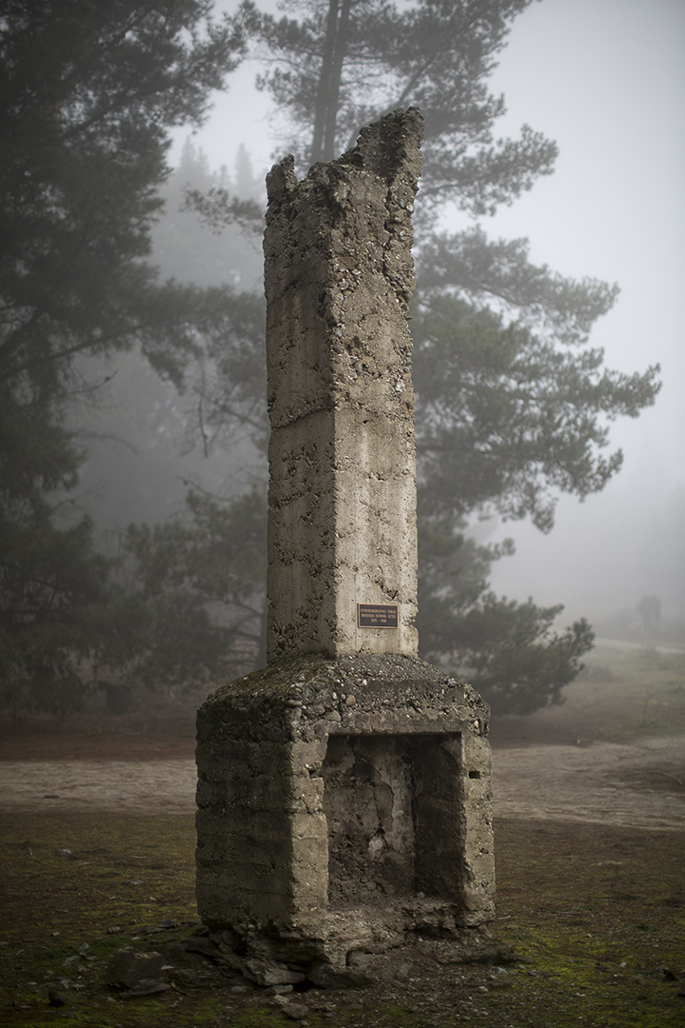 | I love the atmosphere captured here, and the paradox of cold damp conditions with the fire place. The background tree apparently emerging from the chimney is perhaps not ideal. Might it have been better if taken from somewhere a few steps to the right so as to place the top of the chimney in the space between the trees? Either way, the mood is well seen. | Accepted
08 Toi-Toi-Plant | 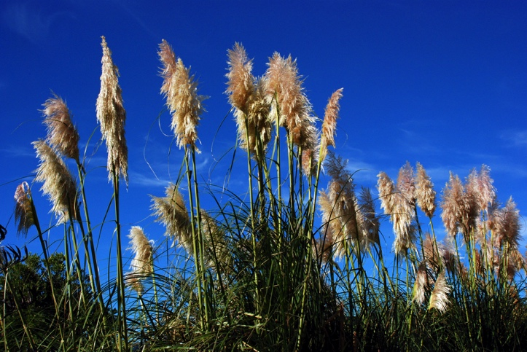 | Good exposure, depth of field and composition in this picture. I like the low viewpoint that avoids distracting background. When I get to the artistic content of the picture, I am not seeing what the photographer wanted the viewer to see. I think it needs a more definite point of interest. | Accepted
09 Piano-Trio | 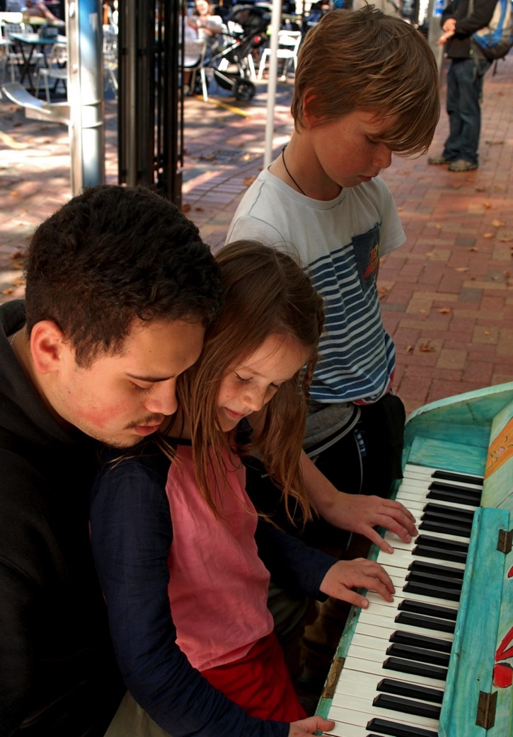 | This image has real charm. My eye goes in a circular pattern to each face in turn and then along the keyboard. The light on the faces is very nice. I do regret the presence of the trousers in the background, but perhaps their occupant was not going to move anyway. Might it be worth reducing the highlights in the upper left? It is a happy image. | Accepted
10 Old-Fitzroy-River-Crossing-WA | 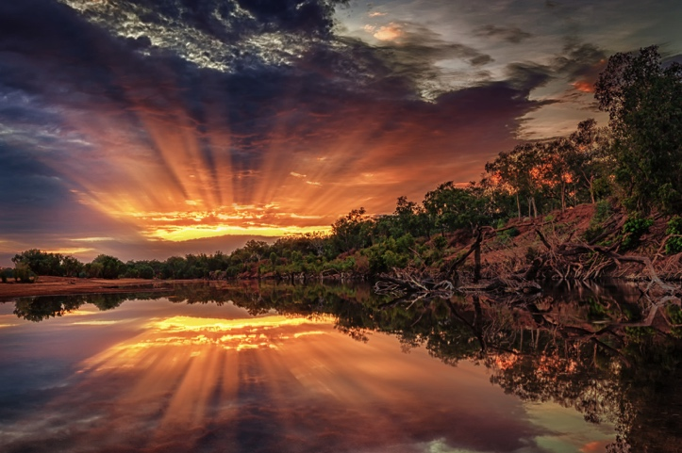 | Sunrise and stillness are well captured in this composition. I love the spreading rays of the sun both in the sky and in the reflection. I am always mindful of distractions around the perimeter of an image and wonder if a small crop in from the lower right corner to make the white patch and the bare logs on the bank disappear would help. | Accepted
11 Sea-cave-on-Wharariki-Beach | 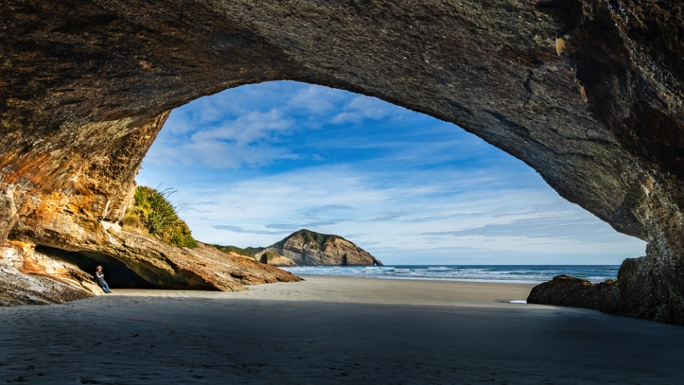 | This nicely constructed image makes good use of the shapes of the headland and the cave. I don’t know whether the person in the cave was a collaborator and I struggle to decide whether he or she helps or hinders. While the person gives scale, he or she is a distraction from the echoed shapes which To my mind are the main point of the story. A pleasing shot. | Merit
12 Journey-to-the-Stars | 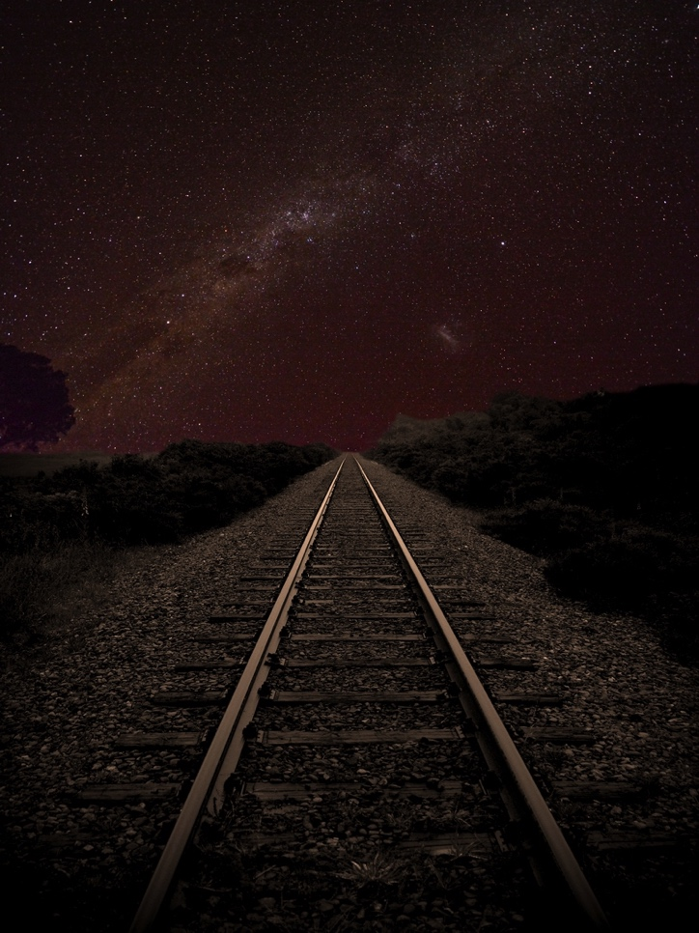 | This clever image leads us down the long trail to the stars. I like the placement and proportions of the glinting steel tracks and the nice night sky behind. Would it help, I wonder to increase the exposure just a little . Congratulations on a good idea well executed | Merit
13 Lone-Gull | 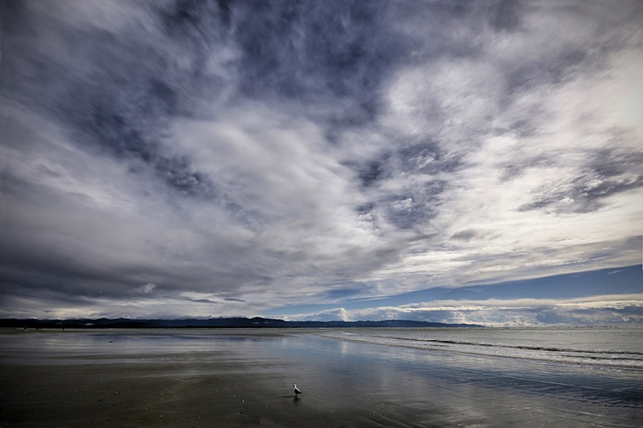 | Land sea and sky are brought together to make a pleasing image which is well composed and well exposed. The question I am left with is whether or not the gull is needed. It is still a nice image if the gull had flown. On the other hand, its presence adds a quirky something to the image. I vote for the gull to stay. | Merit
14 Walk-on-by | 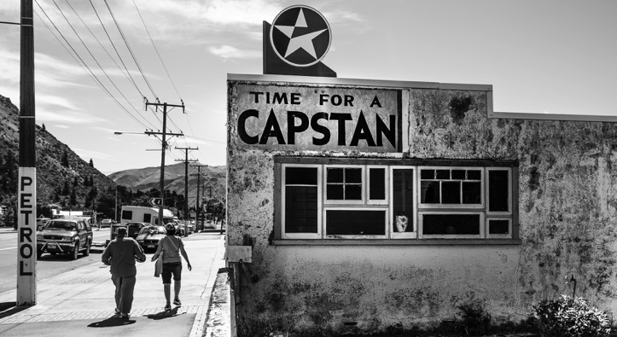 | The photographer takes us back in time. Only the recent cars and perhaps the time-worn paint on the building tell us that this is a recent image. I cannot imagine this image working so well in anything but monochrome. I wonder if this historic advert falls foul of current tobacco advertising rules? | Merit
15 Hay-Barn-of-the-Ahuriri | 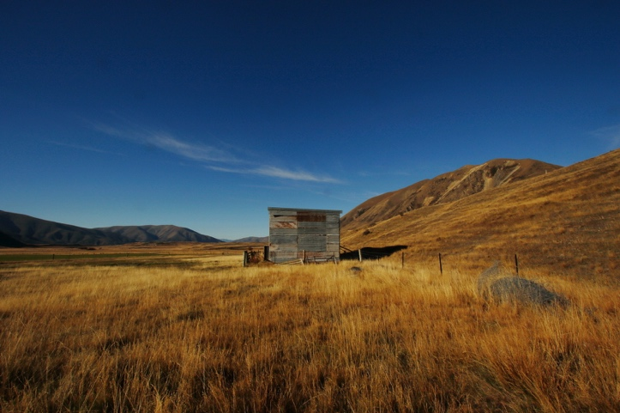 | This picture nicely catches the splendour of the landscape and the golden colour of the season. The photographer has placed the hay barn very centrally. Might it work as well if the roll of fencing wire on the lower right were excluded? | Merit
16 Upper-Rakaia | 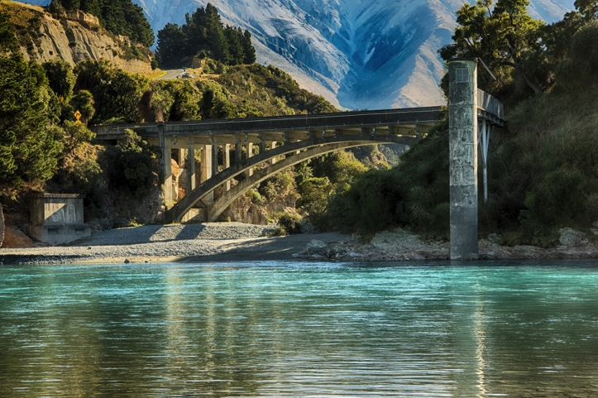 | An elegant bridge in magnificent scenery make a nice image. The exposure is well handled. May I suggest a very minor crop to eliminate the intruding tree on the gravel beach at the left. | Merit
17 The-Elevator | 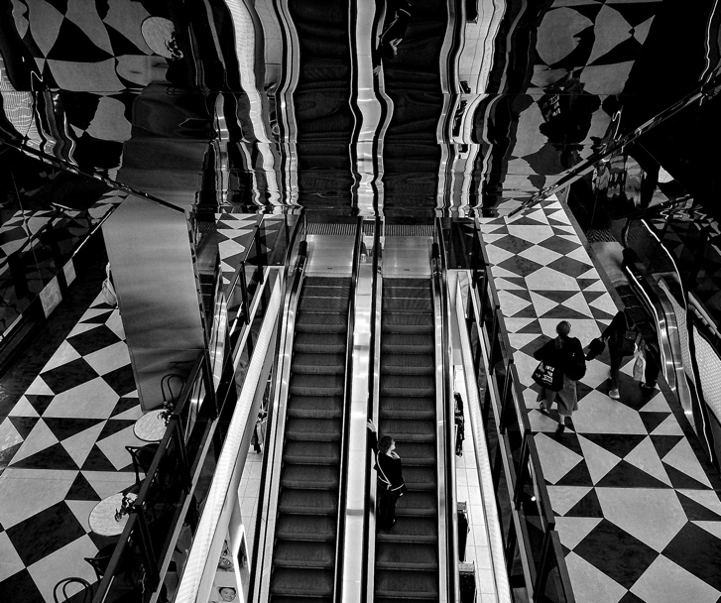 | The photographer has made a powerful image and has gone all the way with the black and white treatment. My eyes seek firm ground, and try to separate reality from reflection. I come up the escalator and then explore the floor on either side, without finding a place to settle. It is a striking image | Merit
18 Girl-Talk | 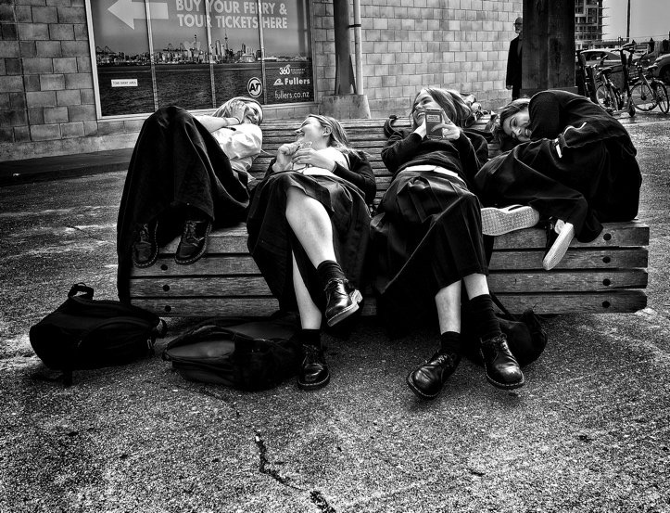 | This image gives me a glance into a strange land to which I can never travel, and yet it is utterly convincing. It has captured a slice of life in a delightful way. The image has a lot of blocked shadows and some blown highlights but all is forgiven because of the great story telling. | Honours
19 Shades-of-Green | 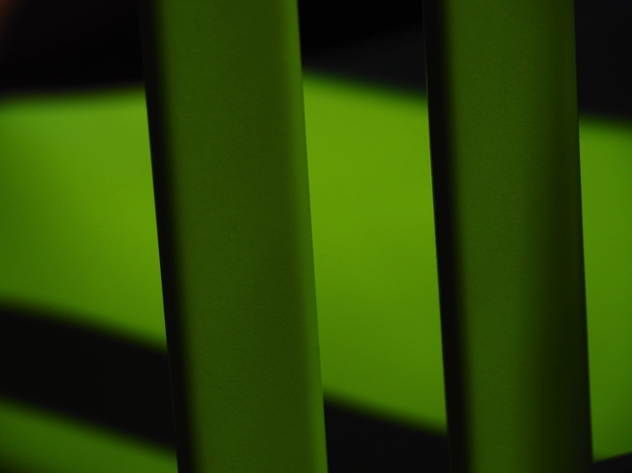 | This image was absolutely worth making. The photographer has seen something in the shapes and colours that many of us will pass by. The patterns evoke a positive response in me and I commend the photographer for his or her seeing. | Accepted
20 Pedestrian-Crossing | 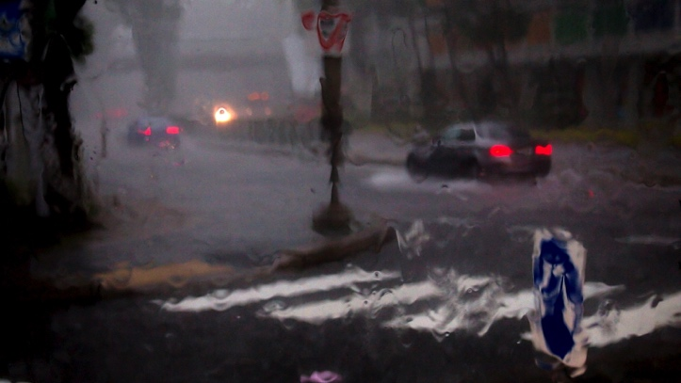 | The essence of winter traffic is presented in this picture. The water running down the window distorts but does not fully hide the reality of the weather outside, and the white stripes of the crossing help us to make sense of the scene. Well made. | Merit
21 Water-Strider | 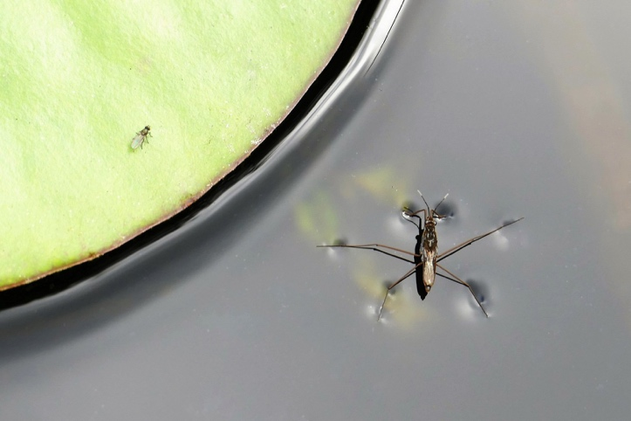 | This is a fascinating image that is a cross between a macro nature shot and abstract art. I presume the green area to be a leaf resting on or close to water. The two insects are beautifully sharp and the right hand one’s interaction with water tension is very well caught. I am seeing three separate images here … each of the two insects and the leaf and water. | Merit
22 Feeding-A-Young-Starling | 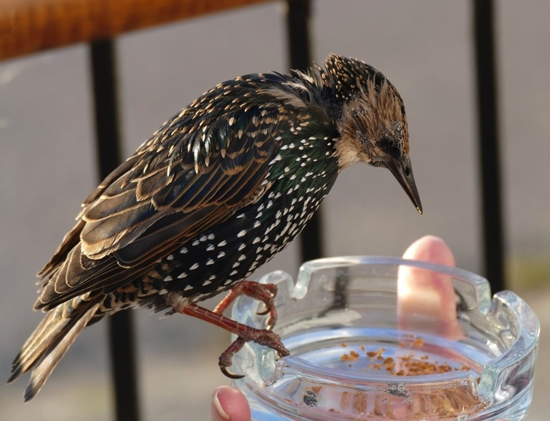 | A story is being told in this image, of a small bird perched on a glass ash tray held by a person. It is an unlikely combination in normal circumstances but the story is well told. The starling is nicely sharp and its plumage well exposed. The direction of the light prevents any catch light in the bird’s eye, and as a minor quibble, if the whole image was made a centimetre or two to the right, the distracting shadow across the tail feathers would not be there. Well done | Accepted
23 Vicky | 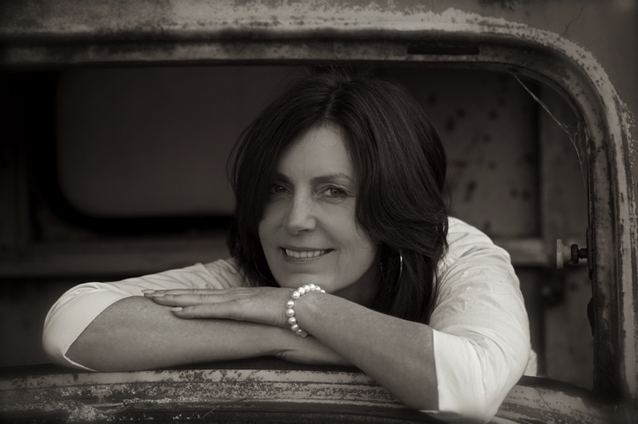 | The portrait of Vicky is a pleasant one, and I speculate that it is made with natural light. I might have liked her right eye to have had a little less shadow. Many portraits are made of attractive woman in rough industrial settings. In this case, the photographer has chosen the glassless front window of an old truck cab, and it has a certain charm | Accepted
24 Grid-Lines | 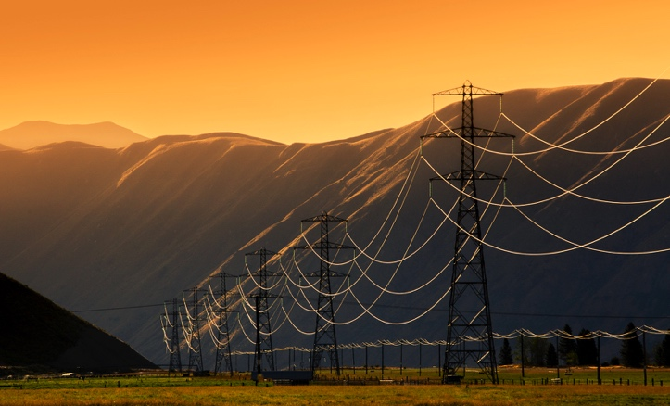 | I love the looping progress of the glittering high tension wires against the shadowed hills, and the echo in the local distribution lines in the background. All the leading lines take us into the entrance of the valley. This image really makes good use of the fabled golden hour. | Merit
25 Early-Morning-Glow | 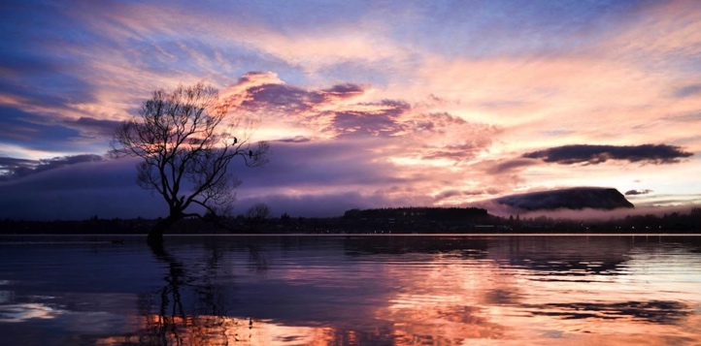 | The photographer shares with us, the rewards for getting out of bed early. I like the composition and think the wide aspect ratio suits the image well | Merit
26 Centre-of-Attention | 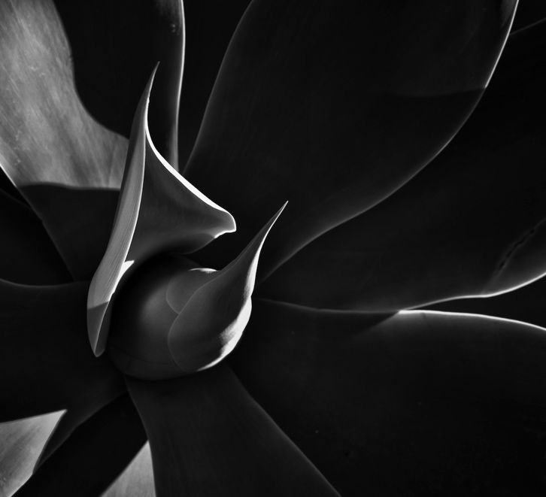 | The photographer has seen an artistic possibility that many of us would walk by. The image is well made and I like the placement of the various elements of the plant. I wonder if the deliberate under-exposure is carried a little too far. A pleasing image | Accepted
27 Seeing-double | 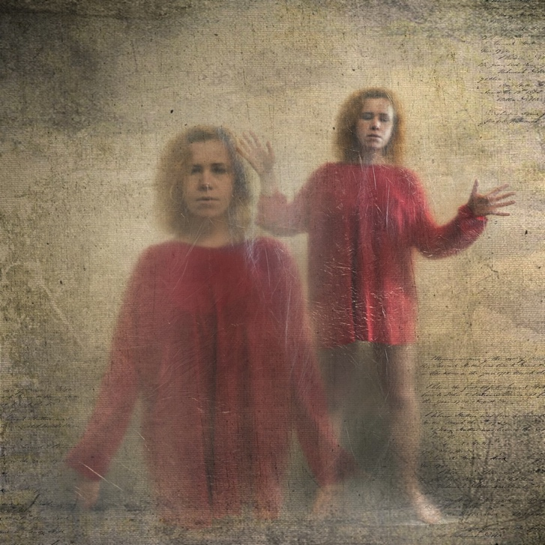 | The skilful combination of two exposures and the use of a manuscript as a textural overlay has resulted in a powerful finished image. I am not sure what message the photographer intended but the expression on the face of the model at the rear is disconcerting. Otherwise a very fine image. | Merit
28 Smoke-gets-in-your-eyes | 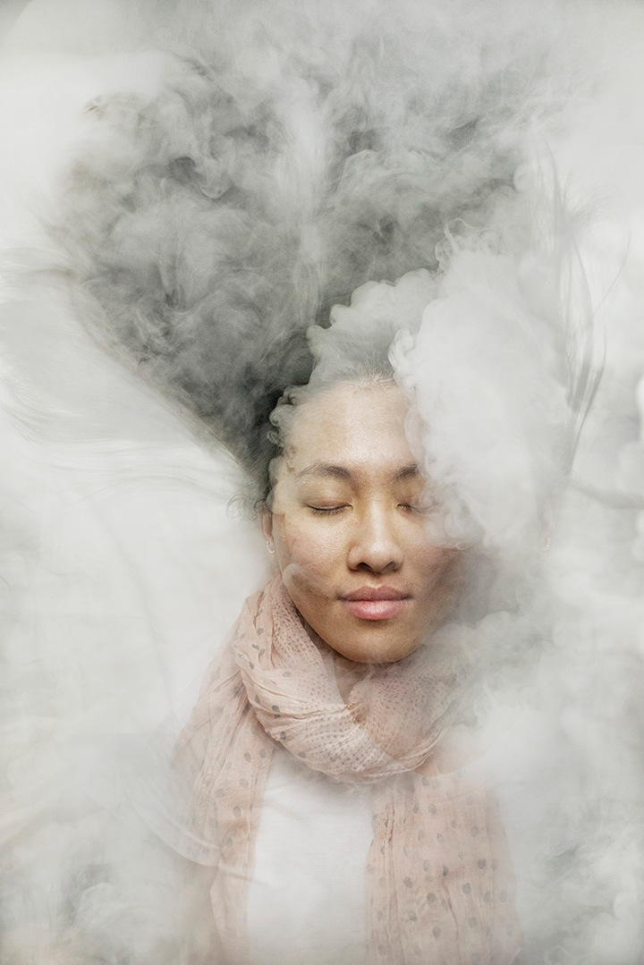 | This is an idea worth exploring, though I hope the model was not actually exposed to this volume of smoke. It’s dangerous for a judge to guess how a result was achieved but I speculate that we are seeing a picture of the model on which a picture of the smoke is superimposed. Would it be a better outcome if the model’s face occupied a larger proportion of the image Nicely exposed. | Accepted
29 riding-high | 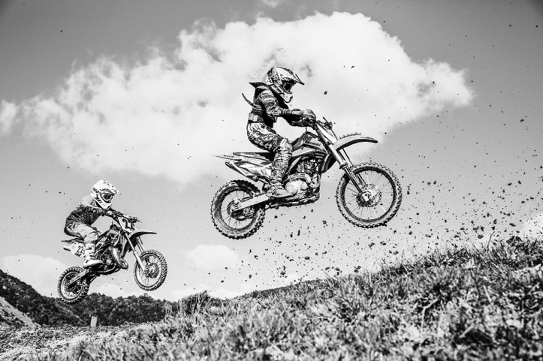 | What an excellent point of view the photographer has chosen to capture these two airborne competitors. I presume the flying mud to be from the preceding bike. I suspect that this was made at a very high shutter speed and as a result the wheels which should be spinning are frozen … I recommend a much slower shutter speed and rely on good panning rather than a fast shutter to get the subjects in sharp focus. Well made. | Merit
30 SEAGULL-@-BROWNSBAY | 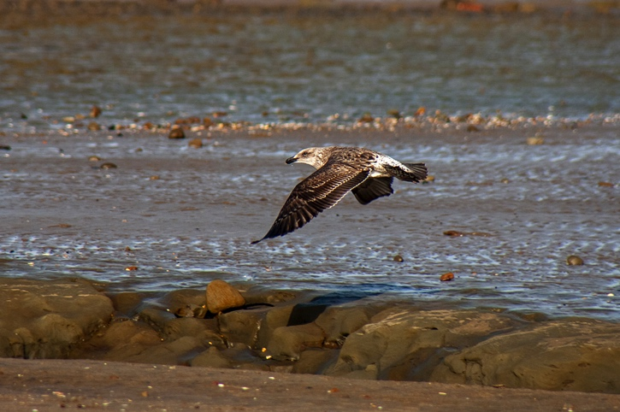 | The passing gull has been well caught, and the tones of this juvenile match rather nicely with those of the landscape. Bird photography is often limited by the reach of our equipment, and in my opinion this is just a little too far away so the bird is relatively small in the frame. Nicely exposed and sharp. | Accepted
31 Gannet- | 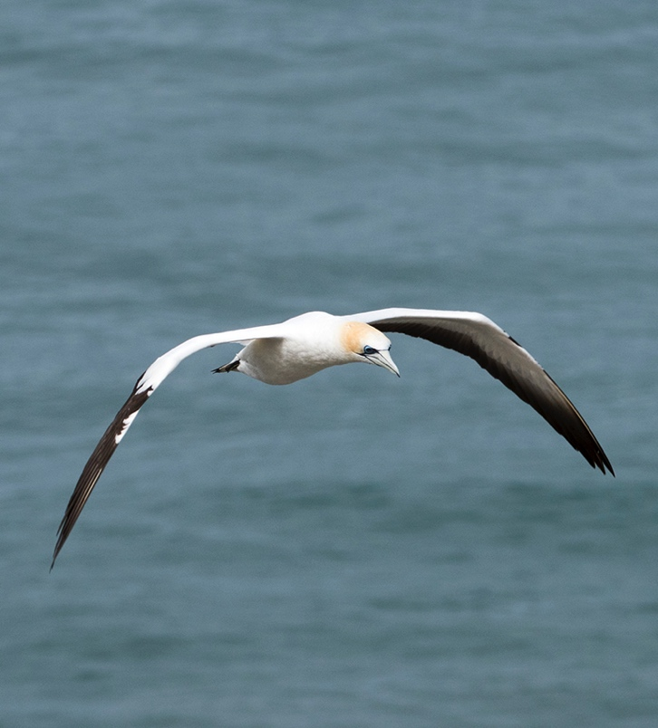 | The picture of the gannet is well made, and the bird is sharply caught. Would it have been a more compelling image if the long side of the frame were horizontal, and there was some more space in front of the bird? | Accepted
32 Kea | 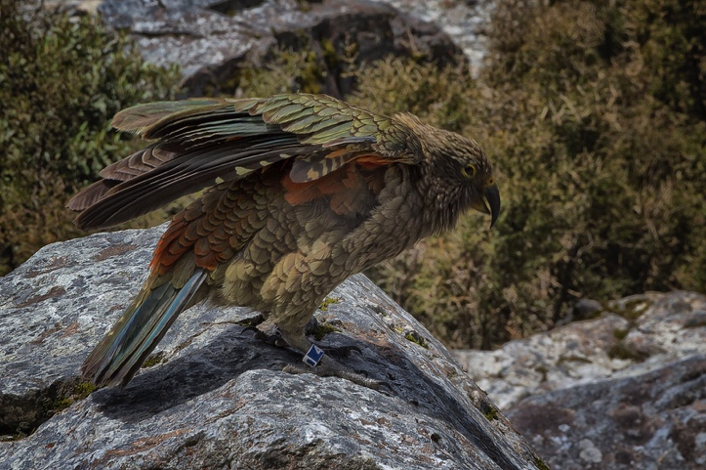 | Nicely caught, with all the essential details in sharp focus. Though the bird’s colour is an essential part of the story, I wonder if it would be a more impressive image if the camera were lower and more at the bird’s eye level to contrast its colours with the rocks. Nicely done | Accepted
33 Rose | 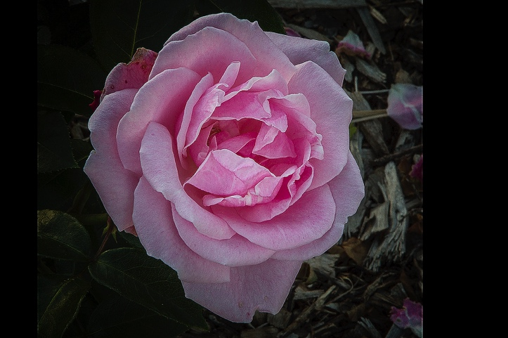 | The flower is beautiful and well seen. I wonder what is happening in the presentation of this image which seems to be an almost square crop inside a rectangular file. It is almost as if it were a picture of a picture. I am disturbed by the vertical lines of highlights on the edge of the actual image inside the black borders. | Not awarded
34 Early-light | 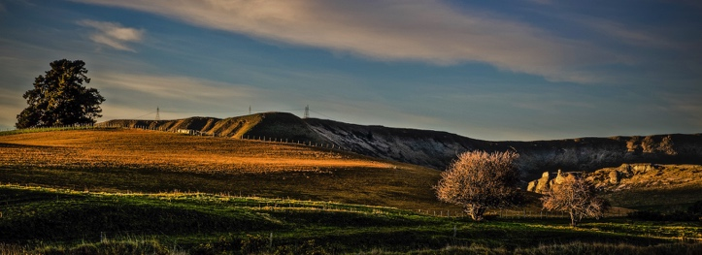 | This is a pleasing panorama. My eye moves from the single tree at the top left to the two trees lower right. I like the long shadows across the rolling landscape. | Accepted
35 small-and-delicate | 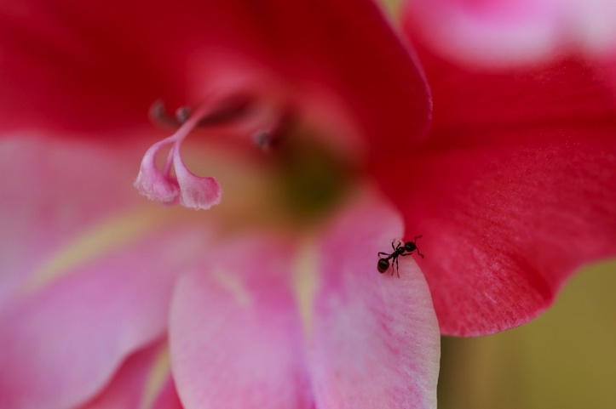 | The ant on the edge of the petal is nicely caught. The photographer has chosen a shallow depth of field so that we not only have the ant, but also the petal in the upper left seemingly appearing from nowhere competing for attention. | Accepted
36 Why-They-Empty | 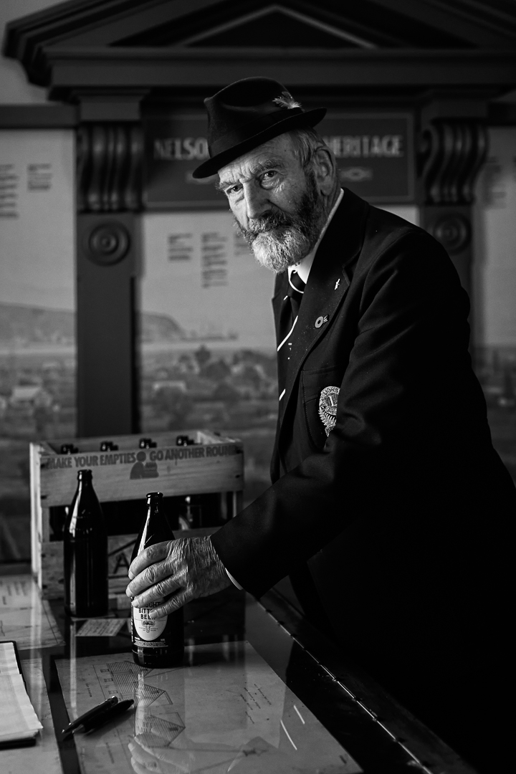 | A well made study of a distinguished looking model. For my taste, the exposure need not have been quite so dark. I like the pose and the subject’s direct engagement with the camera. | Accepted
B Grade
01-abandoned-cottage | 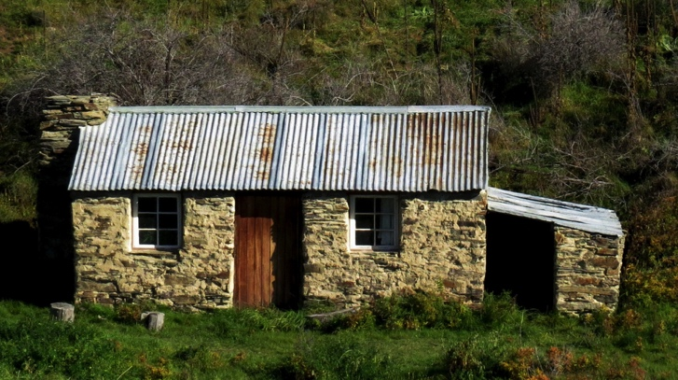 | The old cottage is well documented in this image. The stonework is sharp and well exposed. Might the shadows in the windows and the lean-to on the right be lifted a little? | Accepted
02-autumn-through-the-windscreen | 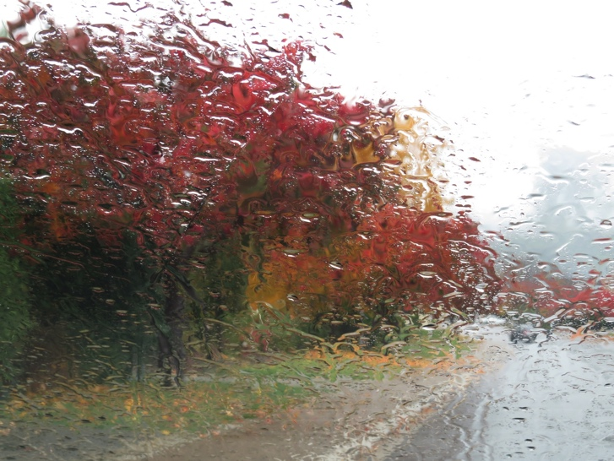 | Well done on seeing the possibility beyond the obvious. Autumn colours in a heavy rain work nicely. | Accepted
03-Home-Spun | 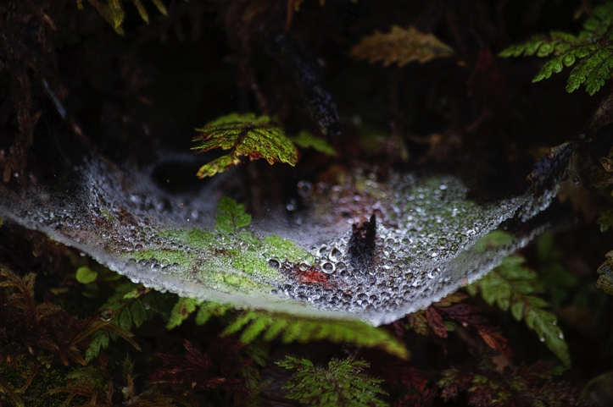 | What a deeply mysterious image. The photographer has done very well to catch the droplets in the web and the fern frond centre left so clearly. I like the very natural vignetting | Merit
04B-Ground-Cover | 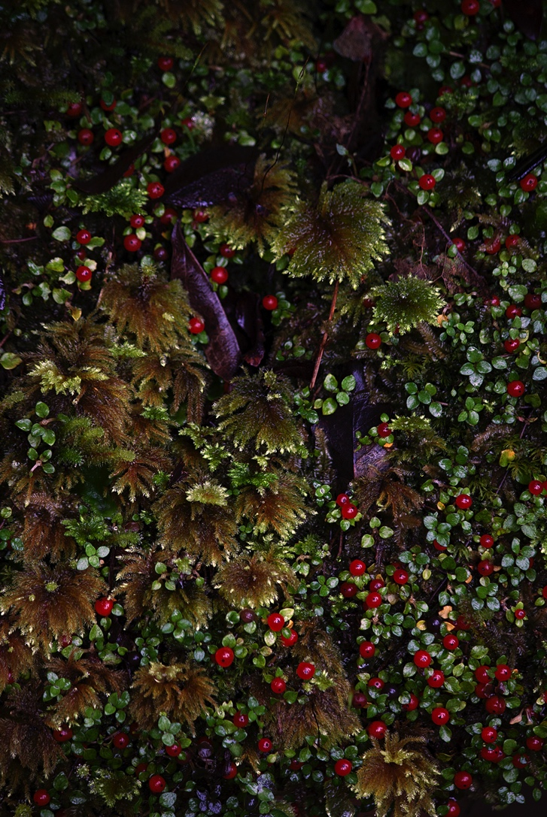 | The photographer has seen the possibilities in the various mosses and other plants on the forest floor. My eyes are caught by the plants just above centre and I wonder if the exposure might be lifted a little to reveal more detail. | Accepted
05-No.9-Birdlings-Flat-Bach | 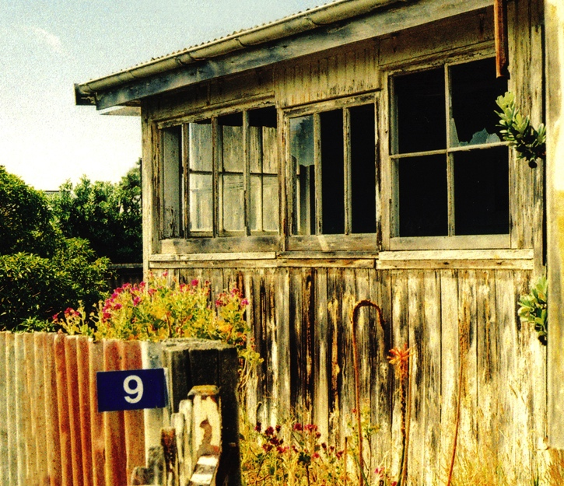 | The angle from which this old house is viewed adds to its character. Though the number seems to belong to a different era, the photographer has done well to allow it to stay. | Merit
06-Dahlia | 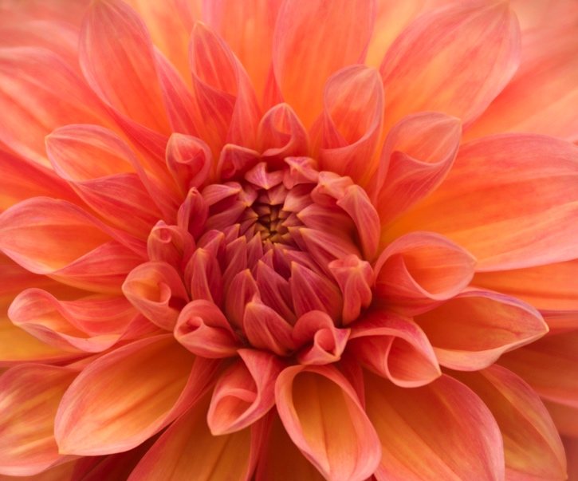 | The dahlia has been well taken to produce a pleasing image. Nevertheless the picture is of nothing but the flower and I think it needs some artistic input from the photographer to do well. | accepted
Prints A
Out of the Fog |  | Here is a story, well told, full of mystery, beautifully executed. I love the monochrome treatment and admire the choice of a sepia tint. I have no suggestions for improvement. | Honours
Contemplation |  | This image visits an often photographed scene, and differentiates itself with the contemplative person, the ice on the decking and the mist on the water. Very nicely done. | Merit
Cave Creek |  | A difficult scene is nicely caught here. The photographer resisted the temptation for a long exposure and blurred water and I think that was a good choice in this case. The depth of field and the exposure are beautifully managed | Merit
Monarch Wing Detail |  | Here is mastery of the macro genre. We see intimate detail and perfect exposure. | Honours
That tree |  | The Wanaka tree is nicely caught here, in a way that many others have done before, You need to find a way to make this image uniquely yours. | Accepted
Little Feet |  | Tiny feet are nicely photographed. The image is sharp in all the places it should be. Other versions I have seen of this idea avoid the distraction of the infant’s diapers in the background. It is a charming image nevertheless | Accepted
Burnside Church Wairarapa |  | The simplicity of the Burnside Church is shown well. The contrast with the impressively dark clouds is pleasing. Would it have been possible to lower the brightness of the car park gravel under the tree to the right of the church? Contrary to the label on the back, definitely not in the Manawatu | Accepted
South Island Robin, Petroica australis |  | This lovely portrait of the robin catches its fearless nature well. The all-important eyes and beak are sharp as are some of the breast feathers while everything else fades into softness. The background is beautifully separated | Merit
Gavin – Reefton Miner |  | This is a beautiful portrait, well made with great catch lights in the eyes. I wonder if the depth of field might have been managed to make the mouth sharp. And might the blown highlights in the beard have been toned down? Nevertheless, a pleasing portrait | Merit
Briar Berries |  | The photographer has provided a superb illustration of the briar berries. It is beautifully sharp and very well separated from the nicely subdued background | Honours
Under the Grime |  | This will surely be a family heirloom. Every feature of the child’s face is sharp and the exposure has been well managed. | Merit
Show Off |  | The peacock putting on its display is irresistible. The exposure is perfect, and every aspect of the bird and its plumage are sharp. I find no fault with this | Honours
Prints B
Wellington Windows |  | The geometry of the Deloitte building is eye-catching and the photographer has presented it very well here. I wonder if it would be a better picture to zoom out so as to include the next diagonal meeting point on the right. Well done (I note some surface damage to the print in the lower right which occurred before I received it, but this did not affect the assessment) | Merit
Red Traffic Lights |  | I like the composition and the exposure. I am curious about the interrupted light trails and wonder whether the photographer used one of the composite-building features that some cameras have. Would it have been better with continuous trails? Perhaps, but it is nice as it is. | Accepted
It was a privilege to assess your images. To those who achieved high results, congratulations on your fine work. To those who were treated less kindly, please remember that the role of the assessor is to express an opinion, so it was just my opinion. Please don’t be discouraged, and do keep trying. Thanks again.
Brian

